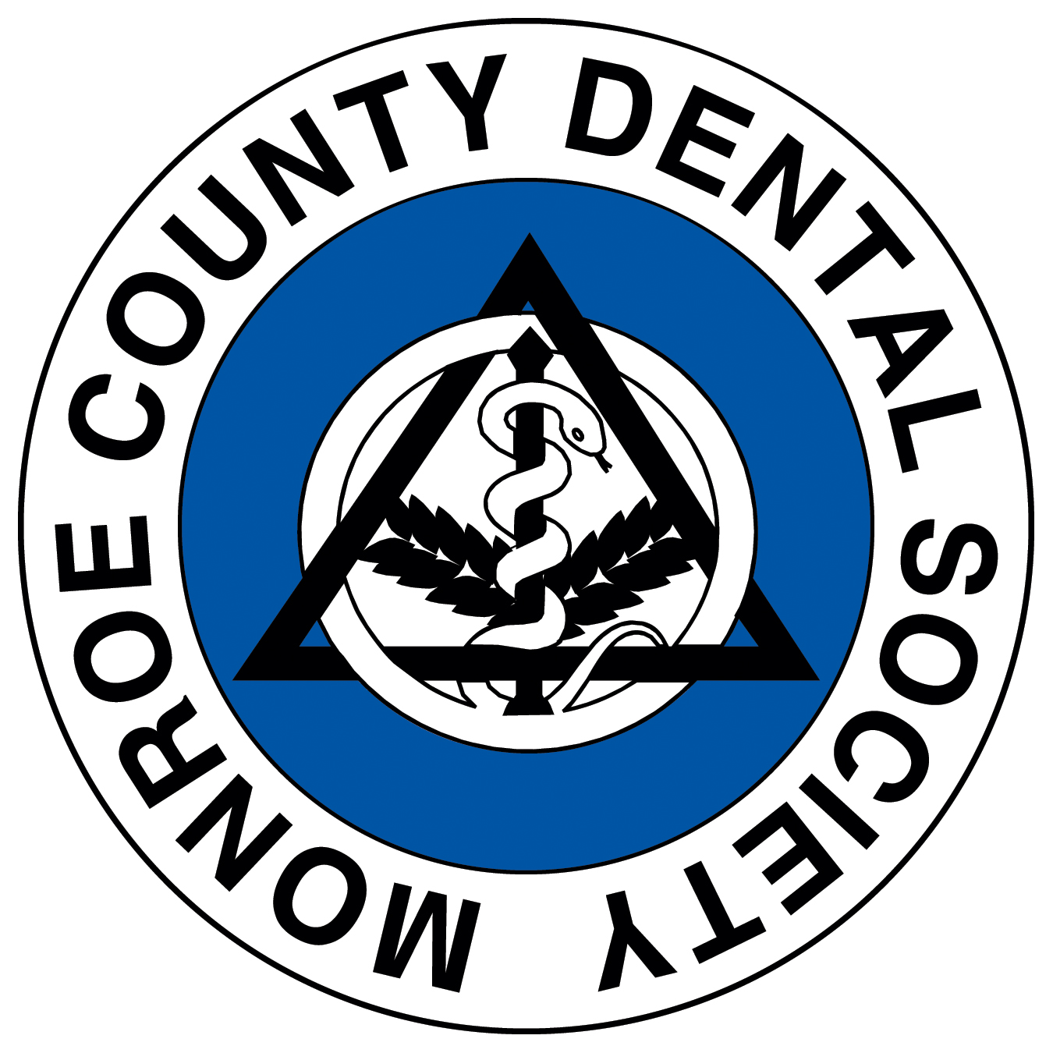

MONROE COUNTY DENTAL SOCIETY

Rochester Dental Study Club

WEDNESDAY, April 26, 2023

ZOOM 6:00 pm until 8:00 pm – 2 MCE Credits

“Surgical Decision-Making & Implant Prosthetics for Anterior Esthetics”

Presented by Dr. Gabriela Carranza

Log-in begins at 5:45 pm •• You must be on for the entire meeting for MCE credits.

Session Description:
Zirconia and lithium disilicate are amongst the most common materials used in modern restorative dentistry, for both natural teeth and implant prosthesis. In the last years, an increasing number of studies provided guidelines for rational use, giving advantages and limitations of a specific material, and taking into account their mechanical, optical and biological properties. Managing the process of bonding and cementation is also extremely important to the long-term success. This presentation highlights material selection in fixed prosthodontics based on the clinical scenarios and specifically defines protocols with relevant research.

Learning Objectives
At the conclusion of this course, participants should be able to:
1) Discuss how to select the restorative material based on a specific clinical application
2) Understand the different approaches available today and specifically define protocols with clinically relevant research
3) Outline pitfalls to avoid in managing the cementation and bonding process of these restorations

Dr. Carranza believes in the principles of lifelong learning and is passionate about improving oral health. She has studied dentistry for more than 15 years, including a 3-year residency in Prosthodontics at New York University and an implant fellowship at the University of Rochester’s Eastman Institute for Oral Health. As the owner and a prosthodontist at Victor Prosthodontics, she is committed to ensuring that all her patients receive the absolute highest quality of care available. Dr. Carranza has published several studies in peer reviewed journals and received several awards for her work in academia. She is an assistant professor in the Prosthodontic Department, Eastman Institute for Oral Health at the University of Rochester. Dr. Carranza lives in Rochester, NY with her husband, Damian.

Monroe County Dental Society is a component of the 7th District; recognized as a CERP provider through NYSDA.
- Continuing Education (CE) credits are awarded for all lectures that meet the NYSED requirements.
- One hour of credit is awarded for each 50 minutes of presentation attended.
- CE forms for NYS Continuing Education requirements will be given to each attendee when checking in at registration.
- To verify attendance, a four digit code, read at the end of each seminar must be marked on the CE form.
- After completing the form please bring the white copy to the registration table before leaving.
- The yellow copy is for your own records. It is recommended that you retain copies of all your CE forms in case of audit.

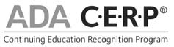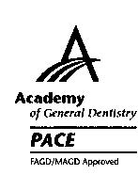

ADA CERP is a service of the American Dental Association to assist dental professionals in identifying quality providers of continuing dental education. ADA CERP does not approve or endorse individual courses or instructors, nor does it imply acceptance of credit hours by boards of dentistry.
Concerns or complaints about a CE provider may be directed to the provider or to ADA CERP at www.ada.org/goto/cerp

MONROE COUNTY DENTAL SOCIETY

Rochester Dental Study Club

WEDNESDAY, April 26, 2023

ZOOM 6:00 pm until 8:00 pm – 2 MCE Credits

“Surgical Decision-Making & Implant Prosthetics for Anterior Esthetics”

Presented by Dr. Gabriela Carranza

Program Cost: MCDS member no charge (included in your 2022-2023 MCDS membership)
$100.00 NON-MCDS member
$50.00 Each staff person (of MCDS Member or non-MCDS member)

Course Credit: 2 MCE Credit Hours

Name: (please print) Attach a list of additional attendees if necessary _______________________________________________________________________________________________________________

_______________________________________________________________________________________________________________

Mailing Address: ____________________________________________________________________________________________

_______________________________________________________________________________________________________________

Phone #:_____________________________Fax #:__________________________ADA #_________________________________

Email Address (for registration confirmation): _____________________________________________________________

Payment Method:
Please make checks payable and return to: Monroe County Dental Society
155 Culver Road, #200, Rochester, NY 14620

Credit card payment: Register on-line: https://www.7dds.org/resources-faq-pages/events/mcds-rochester-dental-study-club-1
Please note there is a convenience fee for credit card payments.

Thank you to our sponsor!

